Level-6

Final Project

Hotel Reservation

Table of Contents

Project Proposal 3

Goals and Objectives 3

Project Scope 3

Project Specifications 3

Target Audience 3

Project Deliverables 4

Resource Requirements 4

Project Tasks and Milestones 4

Project Assumptions 5

Project Report 5

Detail Design 6

Home Page 6

Login Page 6

Admin Advertisements Page 7

Admin Applicant Page 8

Admin Application list Page 9

User Advertisement Page 10

User Detail Page 11

Job Application list Page 12

Project Testing 13

Usability Testing 13

Testing 13

User Manual 16

System Summary 16

System Configuration 16

User Access Levels 16

# 

# Project Proposal

## Goals and Objectives

The aim of this project is building an online application for hotel reservation. In this system there are two types of user. One is admin and other is client. Admin can add, delete, update and check details of the hotels. Delete, and check details for reservations. Admin can manage clients can edit, delete and check details of the clients. Client can view and book a hotel. Also, can manage reservation by deleting and checking the details. With the help of this app user can book hotel on comfort. New clients can sign up. Admin can register new admins.

## Project Scope

This is 20 days project and scope of this project is to build an online web application of hotel reservation where client can view details of various hotel and reserve a room easily. They can also manage the reservation.

## Project Specifications

* Admin can add, delete, update and check details of hotels
* Admin can delete and check details of reservations.
* Admin can manage client by edit, delete and accessing details
* Client can view hotels, check details and do reservation
* Client can manage their reservation.
* Both admin and client can login using their credentials.

## Target Audience

The target audience will be people who travels a lot and business man.

## Project Deliverables

The project deliverables are as follows:

|  |  |
| --- | --- |
| **Deliverable** | **Description** |
| Final Report | complete report of the project |
| Coding | code of the project |
| Documentation | manuals and the documentation |
| Testing | All the testing details of the project will go here. |

## Resource Requirements

* Asp.net MVC Framework
* Identity framework- ASP
* Windows Operating System
* 64-bit Processor and 8-16 GB or more RAM
* Microsoft Office word and excel.

## Project Tasks and Milestones

The table below shows the Project Tasks and Milestones

|  |  |
| --- | --- |
| **Weeks** | **Tasks** |
| 1-2 | Research Analysis and brainstorming |
| 1-2 | Planning and project proposal documentation |
| 1-2 | Design of DB and UI design and implementation |
| 2-3 | Identity framework Implementation |
| 2-3 | Coding- Admin and client part |
| 3-4 | Testing |
| 3-4 | Final Documentation and closing |

## Project Assumptions

* One admin and client will exist while the App is designed and implemented.
* Only registered admin can register new admins
* App will be free and open source.

# Project Report

#### Functional and Non-Functional

The functional requirements and non-functional requirements of this project are as follows:

|  |  |  |
| --- | --- | --- |
| Users | Functional | Non- Functional |
| Admin | * Login/Logout * Manage reservations * Add, edit, delete and check details of hotels * Edit, delete and check details of clients | The non-functional requirements of the project are:   * Browsers compatibility * Device compatibility * Security and high performance * Less load time and less memory. * Limited access for clients. |
| Clients | * Login/Logout * New client can Signup * Can view hotels * Reserve a room * Manage Reservation |

## Detail Design

### Home Page

This is the landing page of the web application. There are home, hotels, reservations, client signup, register reservation admin and login options in the navigation menu.

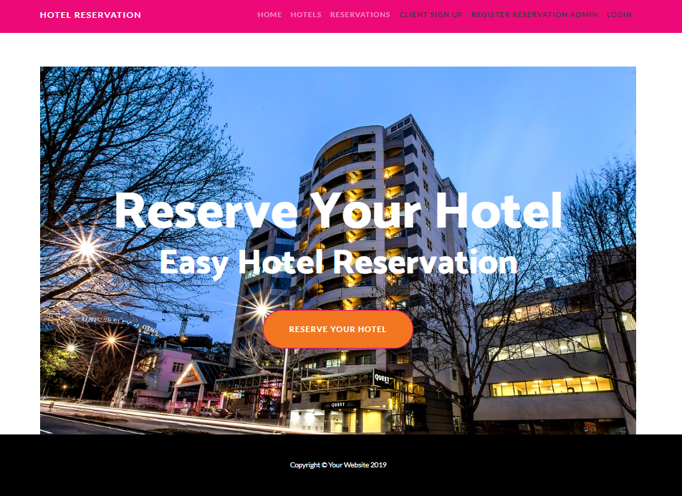

### Login Page

With the help of this page registered admin and user can login to the system by using their valid credentials.

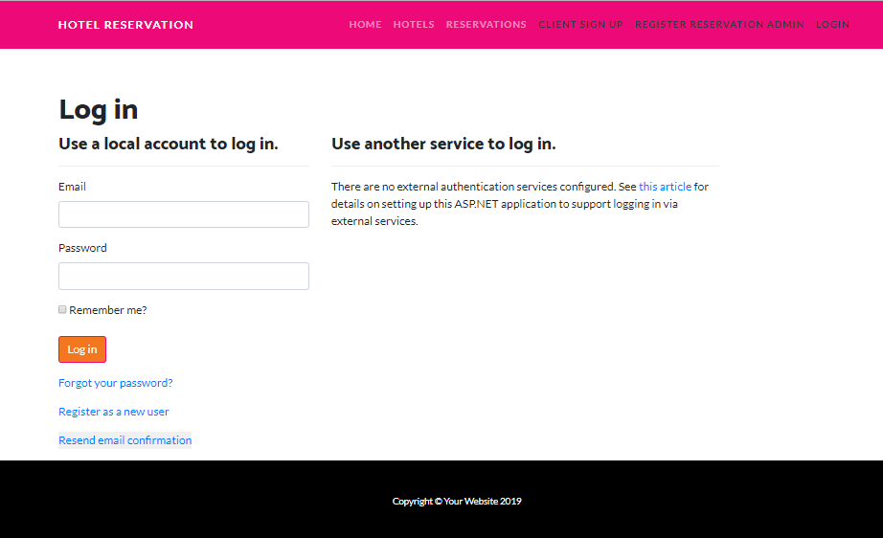

### Hotel Page Admin View

On this Page admin can add new hotels , update existing ones, delete and check the details of the existing ones.

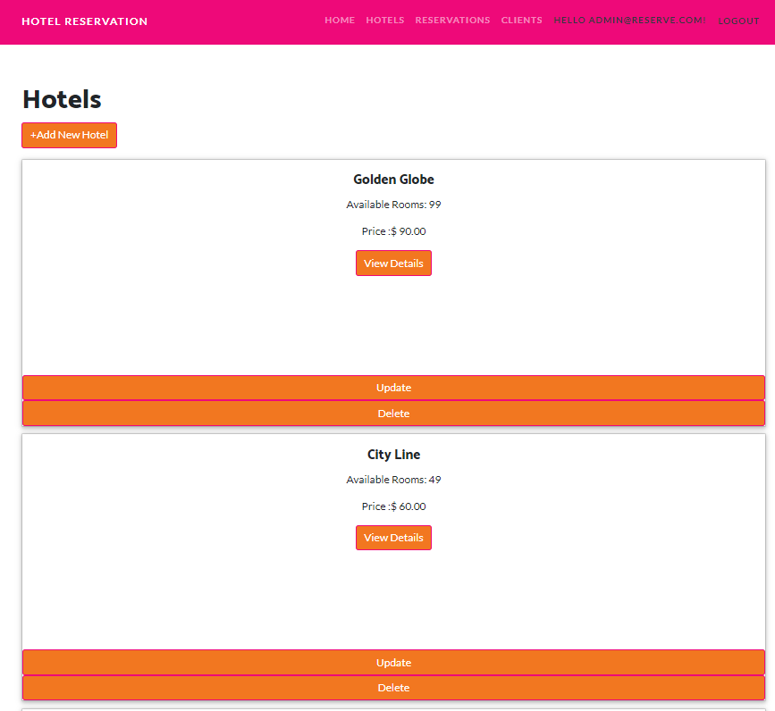

### Client Page Admin View

Using this page admin can manage the clients by editing, deleting and checking details of existing ones.

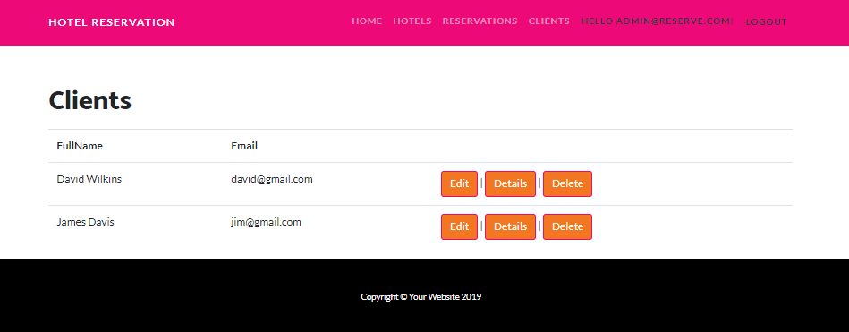

### Reservation Page admin View

With the help of this page admin can manage the reservation.

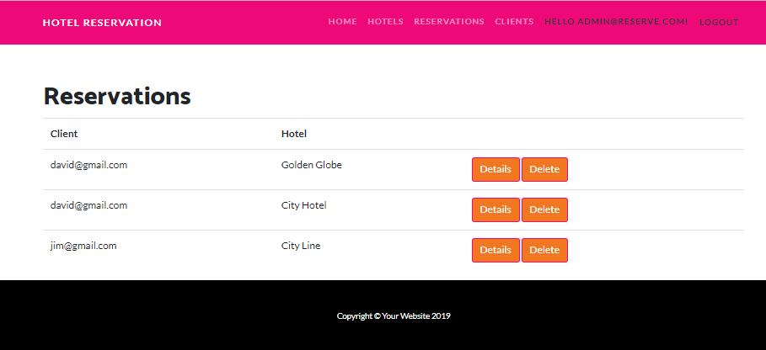

### Client Registration Page

With the help of this page new clients can signup for the application.

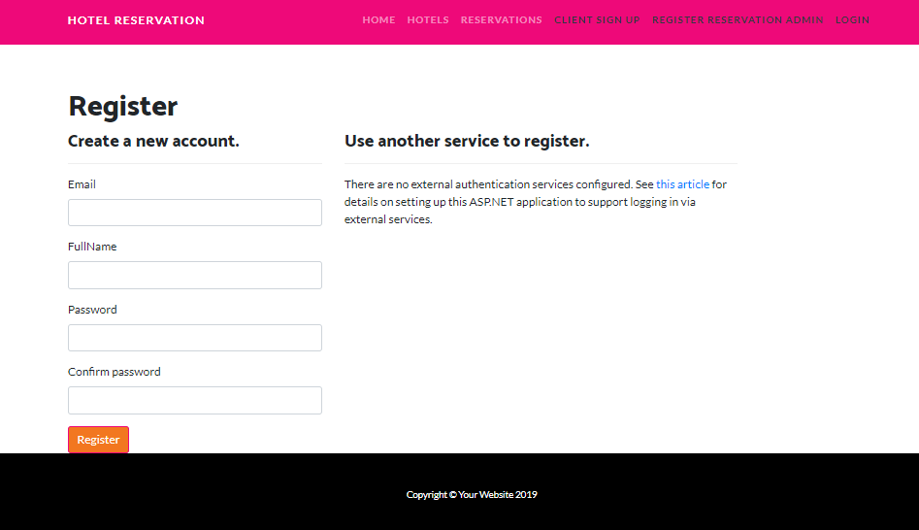

### Hotel Page Client View

With the help this page client can view the details of hotels and can reserve the room.

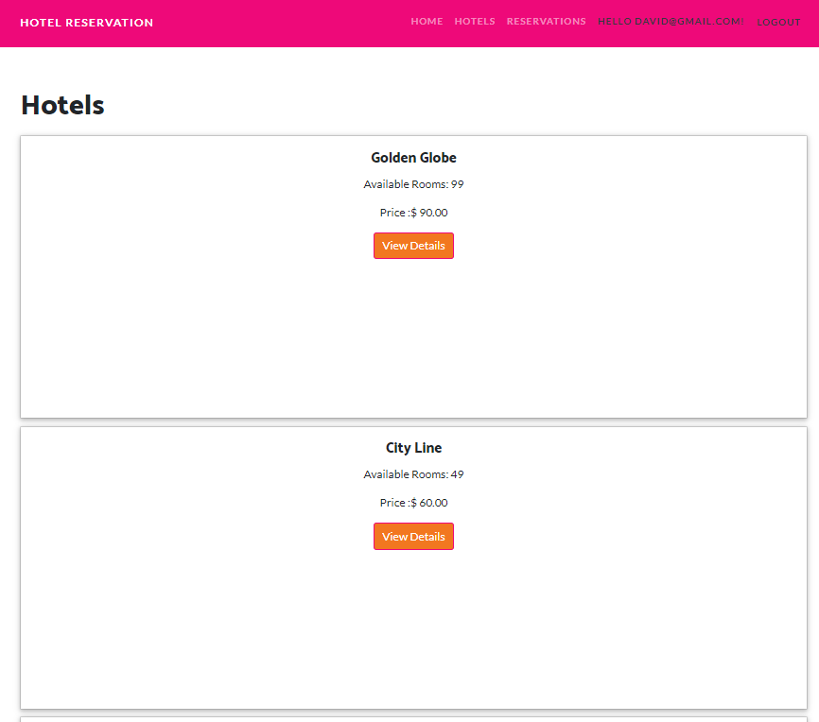

### Reservation Page Client View

With the help of this page client can manage the reservations

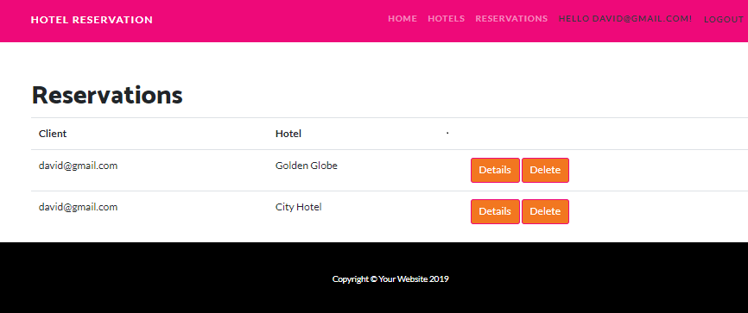

# Project Testing

## Usability Testing

### Testing

|  |  |  |
| --- | --- | --- |
| **Tester – 1** | | **Scale** |
| **No.** | **Question** | **Agree Disagree, Neutral** |
| 1 | Do you think you need the support of a technical person to use this system? | Agree |
| 2 | Is there any inconsistency? | Agree |
| 3 | Is system easy to use? | Neutral |
| 4 | I would like to use this system daily | Disagree |
| 5 | Integration is good | Neutral |
| 6 | I found the system complicated | Neutral |
| 7 | I think most people would learn to use this system very quickly | Neutral |
| 8 | I found the system very challenging to use | Disagree |
| 9 | I can feel confident while running the system | Agree |
| 10 | Lot of knowledge is required to run the system | Agree |

# User Manual

In this system there are two types of user. One is admin and other is client. Admin can add, delete, update and check details of the hotels. Delete, and check details for reservations. Admin can manage clients can edit, delete and check details of the clients. Client can view and book a hotel. Also, can manage reservation by deleting and checking the details. With the help of this app user can book hotel on comfort. New clients can sign up. Admin can register new admins.

## System Summary

### System Configuration

The hotel reservation web application will help to locate the available hotels and clients can book on their comfort.

### User Access Levels

Only registered users can access the features of Hotel Reservation application.

* **Admin:** Full access to the system and all functionalities.
* **Client:** All clients can have limited access to the functionalities.